

Volunteer Hour Reports & Summary

User Guide

Prepared by The Woodland Rangers

UGA MBT Capstone Project

April 28, 2018

**Table of Contents**

Overview 2

DBSecurity 2

Interests 2

Member 3

Membership Type 3

Projects 3

Member Has Interests 4

Security 4

Volunteer Hours 4

Volunteer Hours Report 4

Volunteer Hours Summary 5

The purpose of this document is to review the features, procedures and guidelines of interests, members, and projects. The primary use will be to run volunteer hour reports.

1. Log in at <http://admin.friendsofsmithgallwoods.org/admin> (disregard warning message on top of this page and following pages)
2. This next page will show a row of tabs: DBSecurity, Interests, Member, Membership Type, Projects, Member Has Interests, Security, Volunteer Hours, Volunteer Hours Report, and Volunteer Hours Summary.

Here is an overview of each of the tabs:

**DBSecurity.** The purpose of this section of the site is to set up access to the database. We recommend that this section be avoided and not to create new accounts. The less accounts created, the more security the database will be.

**Interests**. The purpose of this section of the site is to establish a list of interests users can select from the app that is associated with their accounts. As of March 2018, the interest options are: Animal Care, Children’s Camps, Driving Tours, Exhibitor/Presenter, Fishing Shuttle, Gardening, Hike Leader, History, Organizing Events/Projects, Plant Surveys, School Field Trips, Special Events, Trail Work, and Visitor Center Services.

Should the administration want to add another interest option:

1. Click on “Add new”

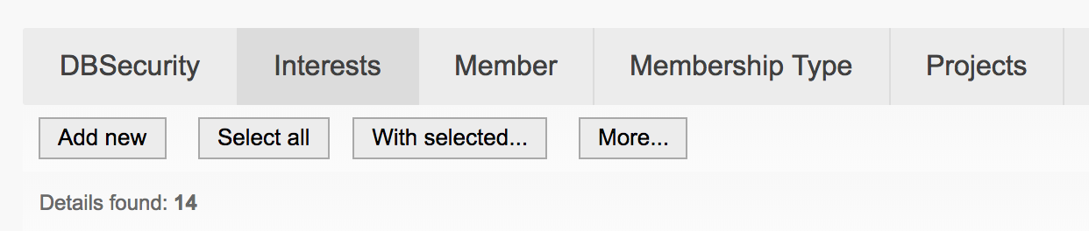

1. You will be transferred to a new page where you can name the new interest. Once the name has been entered, click “Save.”

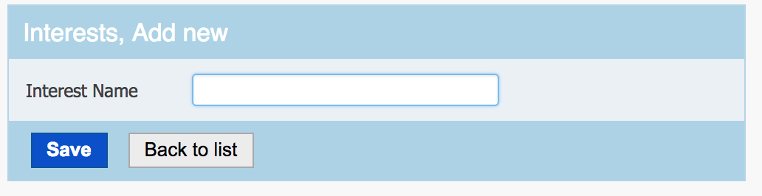

**Member**. The purpose of this section shows the list of members associated with Smithgall Woods. We recommend that this section also be avoided so that accounts will not accidentally be deleted or erroneously changed.

**Membership Type**. The purpose of this section of the site is to establish a list of membership types users can select from the app that best represents their role with Smithgall Woods. As of March 2018, the Membership Types are: No Membership, Individual, Individual-Senior, Family, Family-Senior, Supporting, Patron, Trustee, Individual-DV, and Family-DV.

Should the administration want to add another Membership Type:

1. Click on “Add new”
2. You will be transferred to a new page where you will need to enter the following information:

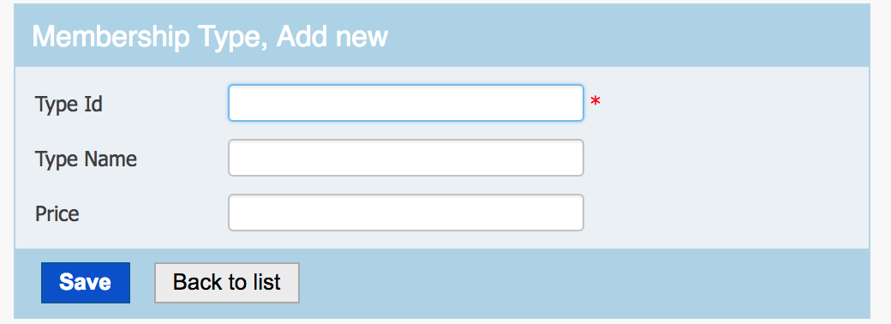

* + Type ID. This is a numerical value and should be sequential order of the other membership types. To see what number should be next, hit the back arrow on your browser and see what was the last number entered.
  + Type Name. This is where you name the new membership type.
  + Price. This is where you denote the amount of money needed to be contributed to attain the new membership type.

1. After the information has been entered, click “Save”

**Projects**. The purpose of this section of the site lists all of the available projects at Smithgall Woods. As of March 2018, there are 18 projects available.

To add a new project to the list:

1. Click on “Add New”
2. You will be transferred to a new page where you will need to enter the following information:

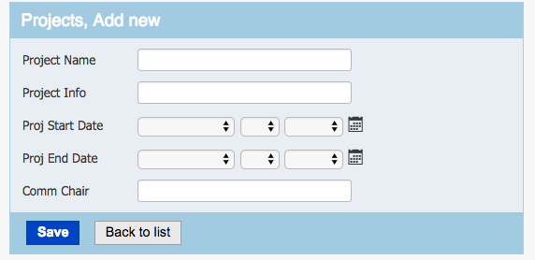

* Project Name: This is the name of the new project
* Project Info: This is a general description of the project
* Project Start Date: This is not a necessary input and can be skipped if desired
* Project End Date: It appears to be common practice to not give a set end date for a project. Majority of already established projects have an in date of 12/31/2099
* Comm Chair: This is not a necessary input and can be skipped or a committee chairperson can be assigned.

**Member Has Interests**. The purpose of this section shows the list of member IDs and the interest ID associated with individual members. We recommend that this section also be avoided so that accounts will not accidentally be deleted or erroneously changed.

**Security**. This section shows members’ emails and when their account was made. We recommend that this section also be avoided so that accounts will not be accidentally deleted or erroneously changed.

**Volunteer Hours**. This section shows the list of members, their volunteer activity and date. We recommend that this section also be avoided so that accounts will not accidentally be deleted or erroneously changed. Reports will be supplied on the remaining two tabs: Volunteer Hours Report and Volunteer Hours Summary

**Volunteer Hours Report**. This section shows the list of all tasks completed by members of Smithgall Woods. The default sorting of this report is by last name. At the top left of the page, there is a search feature should you want to see a particular volunteer’s activities, when a certain project was entered, at what location projects were completed, or for certain project names.



If you were to scroll to the bottom of the page, there is global summary of all hours logged. (Note: This is not a summary of the current page, but a summary of ALL hours logged.)



**Volunteer Hours Summary**. The purpose of this section is to search the database between specific dates to see hours accumulated during that time. The report lists the member ID number, first and last names, and hours of work completed during the specified time. The report is sorted by ID numbers of the respective members.

To run a report:

1. Enter the beginning date and end date of the time frame you would like to search. This is accomplished in one of two ways. Either select the dates from the dropdown boxes or select the dates by clicking on the calendar icon. The top date is the start of time period and the bottom date is the end of the time period.

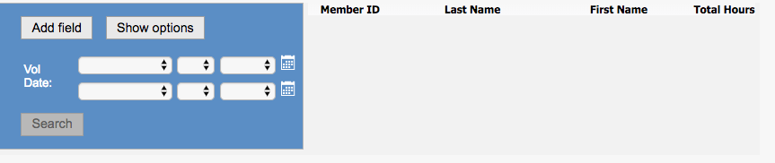

1. Once the dates are entered, select “Search”.
2. Results will be populated and at the bottom of the page will be the global total hours accumulated during that specified time period.

**Example:**

